Call to worship/Opening Prayer
Lord, open the eyes and ears of our understanding today as we prepare our hearts for worship. We want to see you with our spiritual eyes today. Amen.
Hymn: Give thanks to the Lord our God and King (StheF 77)

Give thanks to the Lord,
Our God and King:
His love endures forever.
For He is good, He is above all things.
His love endures forever.
Sing praise, sing praise.
Sing praise, sing praise.

Forever God is faithful,
Forever God is strong.
Forever God is with us,
Forever.
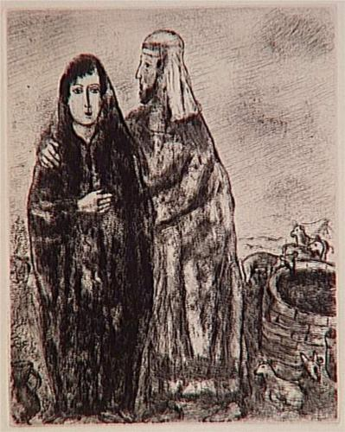
(Repeat)
Forever.

With a mighty hand
And an outstretched arm
His love endures forever.
For the life that's been reborn.
His love endures forever.
Sing praise, sing praise.
Sing praise, sing praise.

From the rising to the setting sun,
His love endures forever.
By the grace of God, we will carry on.
His love endures forever.
Sing praise, sing praise.
Sing praise, sing praise.
Chris Tomlin
2001 Six Steps Music/Adm
by Kingsway Music
Let us pray together
Lord our God, you require truth in the inward parts. We do not wish to deceive but at times we are not honest with ourselves or honest with others. Take any deception, known or unknown and pour out your Spirit of truth. Today we receive your Holy Spirit and ask that as a cool glass of water, you will refresh and cleanse us today of all sin and duplicity. We give you thanks that Christ Jesus came into the world to save sinners. This is his gracious word: ‘your sins are forgiven.’ Amen.
Thanks be to God.
Today’s Reading from the Old Testament
Genesis 29:15-28
Jacob Marries Laban’s Daughters
Then Laban said to Jacob, ‘Because you are my kinsman, should you therefore serve me for nothing? Tell me, what shall your wages be?’ Now Laban had two daughters; the name of the elder was Leah, and the name of the younger was Rachel. Leah’s eyes were lovely, and Rachel was graceful and beautiful. Jacob loved Rachel; so he said, ‘I will serve you seven years for your younger daughter Rachel.’ Laban said, ‘It is better that I give her to you than that I should give her to any other man; stay with me.’ So Jacob served seven years for Rachel, and they seemed to him but a few days because of the love he had for her.
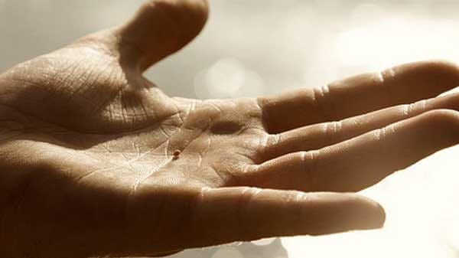
Then Jacob said to Laban, ‘Give me my wife that I may go in to her, for my time is completed.’ So Laban gathered together all the people of the place, and made a feast. But in the evening he took his daughter Leah and brought her to Jacob; and he went in to her. (Laban gave his maid Zilpah to his daughter Leah to be her maid.) When morning came, it was Leah! And Jacob said to Laban, ‘What is this you have done to me? Did I not serve with you for Rachel? Why then have you deceived me?’ Laban said, ‘This is not done in our country—giving the younger before the firstborn. Complete the week of this one, and we will give you the other also in return for serving me for another seven years.’ Jacob did so, and completed her week; then Laban gave him his daughter Rachel as a wife.
Today’s Gospel Reading:
Matthew 13:31-33, 44-52
He put before them another parable: ‘The kingdom of heaven is like a mustard seed that someone took and sowed in his field; it is the smallest of all the seeds, but when it has grown it is the greatest of shrubs and becomes a tree, so that the birds of the air come and make nests in its branches.’
He told them another parable: ‘The kingdom of heaven is like yeast that a woman took and mixed in with three measures of flour until all of it was leavened.’
‘The kingdom of heaven is like treasure hidden in a field, which someone found and hid; then in his joy he goes and sells all that he has and buys that field.
‘Again, the kingdom of heaven is like a merchant in search of fine pearls; on finding one pearl of great value, he went and sold all that he had and bought it.
‘Again, the kingdom of heaven is like a net that was thrown into the sea and caught fish of every kind; when it was full, they drew it ashore, sat down, and put the good into baskets but threw out the bad. So it will be at the end of the age. The angels will come out and separate the evil from the righteous and throw them into the furnace of fire, where there will be weeping and gnashing of teeth.
‘Have you understood all this?’ They answered, ‘Yes.’ And he said to them, ‘Therefore every scribe who has been trained for the kingdom of heaven is like the master of a household who brings out of his treasure what is new and what is old.’

Time to Reflect
What happens when life doesn’t work out the way we want it to? What do we do when we are surprised by the unexpected, or devastated by the unwanted? I guess most of us have experienced those moments. For some it’s the unexpected death of a loved one, friend, neighbour, colleague or acquaintance. For others it’s the break up of a relationship. For still others it may be the breakdown of their physical, or mental health. The unexpected may show up as the loss of a job, or the failure of a business. There are many ways in which, no matter how hard we work, how good we are, or what we do, life just doesn’t give us what we want!
Given a choice, most of us probably prefer a “what you see is what you get” kind of life. If we ask a question, we want to be able to trust that we will get an honest answer. We want a fair wage for a day’s work. We want to know that if we do the right thing, we will get the result we expect and deserve. We don’t want surprises, or hidden agendas. We prefer the stability, order, predictability, and control that a “what you see is what you get” kind of world offers. It makes life easier and more manageable.
The problem is that life doesn’t always work that way. In fact, Jesus says that’s not how the kingdom of heaven works! Sometimes real life, kingdom life, is like a net dragged through the sea. It pulls up both the good and the bad. At other times it’s like a field that you see day after day. It’s always there. Not much ever changes. It’s just an ordinary field like any other field, except that it’s not. Deep within that ordinary dirt, is unseen treasure waiting to be discovered.
Now most of us have been around long enough to know that, despite our desires and hopes, we don’t always get what we want! The good and the bad, the dirt and the treasure, are never far from each other. Nothing is ever as it seems. What you see is not always what you get! Sometimes we are like Jacob in our OT reading from the Book of Genesis - you choose Rachel and end up with Leah. That’s when we have to make a decision about our faith and how, or even whether, we will ever move forward.
It’s more than whether we’re a half glass full or half glass empty kind of person.
Can we trust that there is more happening in life than we can see, or understand? Can we look at a mustard seed, the smallest of seeds, and see contained within it the greatest of shrubs, a tree in which birds nest? Or is our faith limited to what we see here and now, what can be verified by facts and logic, to what fits our desires and expectations?
That’s the dilemma facing many people as they receive what they did not choose. Those are the questions some face in this country, magnified to more than some, must answer as they look for a job, go without food to feed their children, rely on the Foodbank, or struggle to make ends meet. That faith question is the challenge for everyone who has ever thought life was one way and discovered that it was another. That’s where, in the reading from the Book of Genesis, Jacob is today.
For those of you with a Sunday School education, or who were paying attention when it was mentioned in a sermon sometime in the dim and distant past, Jacob bought his older brother’s inheritance for a bowl of soup. Then he and his mother, Rebekah, deceived his father, her husband Isaac, into giving Jacob the blessing that rightfully belonged to Jacob’s older brother, Esau. After all that Jacob fled for his life to Laban, Rebekah’s brother.
Still with me? Now then, Jacob journeys to a new land seeking Laban. He comes to a well. Laban’s younger daughter, Rachel, shows up. She is beautiful and graceful. Jacob shows his affection for Rachel at the well, for he loves Rachel. He and Laban, her father, then work on a deal. The plan is Jacob will serve Laban for seven years for the right to marry his daughter Rachel. At the end of the seven years Laban prepares a great wedding feast. However, Laban will not allow to happen to Leah, who is his oldest daughter, what happened to Esau, Issac’s oldest son. It’s not right for the younger daughter to be given in marriage before the firstborn. Laban knows this and, more importantly, so does Leah. Laban will not allow Rachel to supplant Leah as Jacob supplanted his older brother, Esau. The name Jacob means supplanter – one who usurps, or takes over someone above them from below them!
Well, nevertheless, Laban prepares a great feast. Then after the wedding Jacob goes to meet Rachel in the tent start their married life together. “When the next day arrived it wasn’t Rachel who had become his wife, it was her sister Leah!” Laban has done the dirty, he’s been underhanded. Jacob, the one who had deceived and fled, has now been deceived and trapped himself. Now he’s got to be wondering about that night at Bethel – with the ladder and God’s promises to keep him and go with him. So a wedding, the waking up, smelling the coffee and realising he’d not married the girl of his dreams, but her sister Leah instead are not what Jacob chose, expected, or wanted. It certainly doesn’t sound like the fulfilment of God’s promises. It sounds more like an ancient soap opera.
Sometimes, though, things are not as they seem. Who would have ever thought that the soap opera stories of a dysfunctional family, brokenness, lies and deception, unmet expectations and hopes would become sacred stories? This is true not just for Jacob and Esau, Isaac and Rebekah, Laban, Leah, and Rachel. It is true for each every one of us too.
We each have stories of family dysfunction, sorrow, loss, despair, and brokenness; stories of how things didn’t work out for us, sometimes through our own fault, other times simply by chance, or the circumstances of life. Those stories are probably not the first place we turn to when we are looking for God. That’s not generally where we expect to find God. “What you see”, however, “is not always what you get”, as the saying goes! God is always, somehow, mixed into our stories of dysfunction, brokenness, sorrow, and despair. Just like yeast that is mixed in with three measures of flour. You can’t see it, or separate it out, but it’s there, working, leavening, and transforming the flour into something new and alive.
Even when we choose ‘Rachel’ and we get ‘Leah’, the leaven of God’s life, the leaven of God’s love, the leaven of God’s presence, the leaven of God’s healing is working within us to transform and make our lives anew. The leavening power of God within us can do more than we can ask, or imagine. So, to put it bluntly, profoundly, and in context (glass half full, or glass half empty), what we see is not all we get! Look for the signs of the kingdom of God breaking in, in unexpected ways, in unexpected events, in unexpected places and indeed in unexpected people!
A time of prayer
Dear Father, I thank you for the ongoing work in my life. I know it will continue until you take me home. Thank you for sins forgiven, for a life with you now, and a life with you in the hereafter.
We pray for the Methodist Church, nationally and worldwide.
We pray for the universal Church and the churches that have met through technological means during this time.
We pray for all those who have suffered loss in this present coronavirus situation.
We thank you for every act of kindness done during this time and all the imaginative ways that ministers and lay workers have used to keep in touch with their congregations.
We pray for those who are in needing of healing, physically, emotionally, and spiritually. Lord in your mercy, hear these prayers. Amen
The Lord’s Prayer
Our Father ……
Hymn: Take my life and let it be (StheF 566).

Take my life, and let it be
Consecrated, Lord, to thee;
Take my moments and my days,
Let them flow in ceaseless praise.

Take my hands, and let them move
At the impulse of thy love;
Take my feet, and let them be
Swift and beautiful for thee.

Take my voice, and let me sing
Always, only, for my King;
Take my lips, and let them be
Filled with messages from thee.

Take my silver and my gold,
Not a mite would I withhold;
Take my intellect, and use
Every power as thou shalt choose.

Take my will, and make it thine,
It shall be no longer mine;
Take my heart - it is thine own;
It shall be thy royal throne.

Take my love; my Lord, I pour
At thy feet its treasure-store;
Take myself, and I will be
Ever, only, all for thee.

Frances Ridley Havergal (1836-1879)

A prayer of blessing
Lord, I have heard the good news that you accept and love all people, including me.
Grant that whatever I do this day I will be responding to this love with a humble and thankful heart.
Lord, what we see is not all we get. May I look for the signs of your kingdom breaking in, in unexpected ways, in unexpected events, in unexpected places and in unexpected people, and even in me. Amen.

CCLI no. 3722

